
TEMASEK JUNIOR COLLEGE
Preliminary Examinations
Higher 2

CANDIDATE
NAME
CIVICS  GROUP |  |  | /

CHEMISTRY 9647/02
Paper 2 Structured Questions 17th September 2010
2 hours
Candidates answer on the Question Paper.
Additional Materials: Data Booklet

READ THESE INSTRUCTIONS FIRST

Write your Civics Group and name on all the work you hand in.
Write in dark blue or black pen on both sides of the paper.
You may use a soft pencil for any diagrams, graphs or rough working.
Do not use staples, paper clips, highlighters, glue or correction fluid.

Answer all questions.
A Data Booklet is provided.

At the end of the examination, fasten all your work securely together.
The number of marks is given in brackets [ ] at the end of each question or part question.

For Examiner’s Use
1
2
3
4
5
6
Total

This document consists of 19 printed pages and 1 blank page.
1 | Planning (P) |  |  |  |  |  |  |  | For Examiner’s Use
 | (a) | The enthalpy change of combustion of ethanol, ΔH_{c} can be determined experimentally under laboratory conditions using the following apparatus.  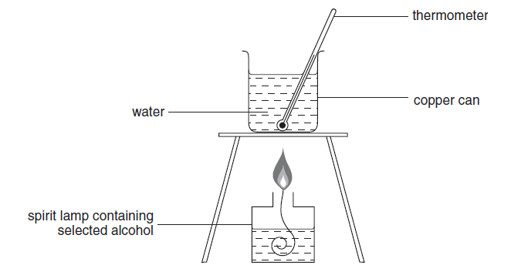
 |  | (i) |  | Using the apparatus shown above and any other apparatus required that is normally found in a school laboratory, plan a step-by-step method to determine the enthalpy change of combustion of ethanol, ΔH_{c}.
 |  |  |  | Show how you would tabulate your results. All necessary measurements should be shown in the table. You may use letters to represent each reading obtained e.g. T₁, T₂.. to represent temperature readings, M₁, M₂.. to represent mass readings etc. |  |  |  |  | For Examiner’s Use
Using the lettered symbols in your table, show how you would process your results to find the enthalpy change of combustion of ethanol, ΔH_{c}.
[4.2 J of heat energy raise the temperature of 1 cm³ of water by 1 ºC]

 |  | (ii) |  | The apparatus shown in the diagram on page 2 and used in the experiment you have described is inefficient as much of the energy released from the burning ethanol is lost to the atmosphere.  Suggest one simple improvement to the apparatus shown on page 2 that will reduce the loss of heat energy to the atmosphere. The suggested improvement should be supported by an appropriate reason.
 |  | (iii) |  | The equations for the complete combustion of the first five members of the alcohol homologous series are shown below.  Methanol: CH3OH(l) + 1½O2(g) → CO2(g) + 2 H2O(l)  Ethanol: CH3CH2OH(l) + 3O2(g) → 2 CO2(g) + 3 H2O(l)  Propan-1-ol: CH3CH2CH2OH(l) + 4½O2(g) → 3 CO2(g) + 4 H2O(l)  butan-1-ol : CH3CH2CH2CH2OH(l) + 6O2(g) → 4 CO2(g) + 5 H2O(l)  pentan-1-ol: CH3CH2CH2CH2CH2OH(l) + 7½O2(g) → 5 CO2(g) + 6 H2O(l)  There is a trend in ΔHc for these five alcohols. Sketch the trend indicated by the equations. |  |  |  |  | For Examiner’s Use
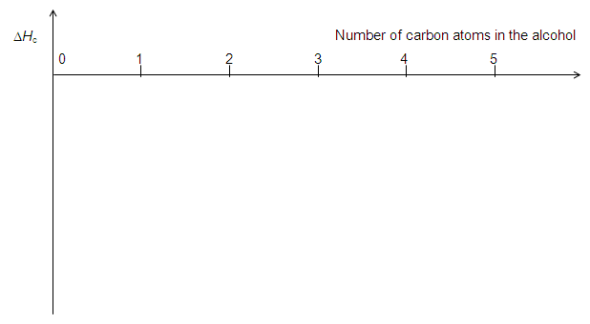
[8]

 | (b) | Labels have come off three bottles each containing an aqueous solution of the following chemicals:  aluminium nitrate  lead nitrate  zinc nitrate  You are provided with the reagents NaOH(aq), NH₃(aq), Na₂CO₃(aq), dil H₂SO₄ and dilute HCl.  Using only the above reagents, but not necessarily all of them, you are to plan a method to identify each of the solutions. Maximum credit will be given for the minimum number of tests to positively identify each of the solutions. Marks will be deducted for additional or unnecessary tests.  Record your expected results in the table below. |  |  |  |  |  |  | For Examiner’s Use
 |  |  |  |  | Experiment | Expected observation with each solution tested and deductions from these observations
 |  |  | 1
 |  | [4]
 |  | [Total: 12]
BLANK PAGE

2 | (a) | Protein built enzymes form complexes with the metal ions, with the protein acting as a multi-dentate ligand. The enzyme catalase, a haem protein containing an iron complex, acts as a homogenous catalyst to break hydrogen peroxide down into water and oxygen.  2H₂O₂ → 2H₂O + O₂ |  |  |  |  |  |  |  |  |  |  |  |  |  |  | For Examiner’s Use
 |  | (i) | Explain the terms in italics. Describe how it increases the rate of reaction.
 |  | (ii) | Referring to relevant Eº data from the Data Booklet, suggest a mechanism for the catalysis of the decomposition of H₂O₂ by Fe³⁺.
 |  |  | [6]
 | (b) | A solution of hydrogen peroxide of original concentration of 5.0 mol dm⁻³ was placed in a bottle contaminated with catalase. The rate of decomposition was measured by withdrawing 10 cm³ portions at various times and titrating with acidified 0.2 mol dm⁻³ KMnO₄. The following results were obtained.  5H₂O₂ + 2MnO₄⁻ + 6H⁺ → 2Mn²⁺ + 8H₂O + 5O₂ |  |  |  |  |  |  |  |  |  |  |  |  |  |  | For Examiner’s Use
 |  |  |  |  | Time / min |  |  |  |  | Volume of KMnO₄ / cm³
 |  |  |  |  | 0  5  10  15  20  25  30 |  |  |  |  | 25.0  19.3  15.0  11.5  9.0  7.0  5.5
 |  | (i) |  | Using a graphical method, confirm that the reaction is first order with respect to hydrogen peroxide.
 |  |  |  | 
 |  | (ii) |  | Calculate the rate constant and state its units. |  |  |  |  |  |  |  |  |  |  |  |  | For Examiner’s Use
 |  | (iii) |  | What effect will the presence of the catalase have on the rate constant for the reaction? Explain your answer.
 |  | (iv) |  | Calculate the concentration of the hydrogen peroxide at the time the first portion was withdrawn. Hence estimate how long the solution had been in the contaminated bottle.
 |  |  |  | [8]
 |  | [Total: 14]
3 | (a) | The colours of the silver halides are used in identifying tests for the hydrohalic acids and also for halide salts. Below are some data for the various silver halides. |  |  |  |  |  |  |  |  |  |  |  |  |  |  | For Examiner’s Use
  Silver halide | Solubility product / mol² dm⁻⁶
  AgCl | 1.6 x 10⁻¹⁰
  AgBr | 7.7 x 10⁻¹³
  AgI | 8.3 x 10⁻¹⁷
 |  | (i) | From the data above, calculate a value for the solubility of AgCl in water.
 |  | (ii) | Discuss, with the aid of relevant equations, the solubility of silver chloride in aqueous NH₃.
 |  |  | [4]
 | (b) | The hydrogen halides can be produced from the reactions between the halogens and hydrogen gas.
 |  | By quoting appropriate data from the Data Booklet, explain the trend in the thermal stability of the hydrogen halides.
 |  | [2]
 | (c) | One of the halogens, chlorine, can be produced from the electrolysis of a concentrated sodium chloride solution (brine). Brine is passed into a diaphragm cell as illustrated in the diagram below at room temperature.  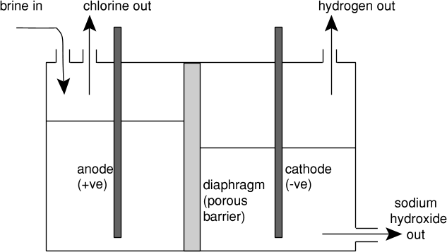  gas out  gas out |  |  |  |  |  |  |  |  |  |  |  |  |  |  | For Examiner’s Use
 |  | (i) | Write the ion-electron half-equation for each of the electrode reactions.
 |  |  | Anode
 |  |  | Cathode
 |  | (ii) | Explain, with the aid of an equation, what will happen if the diaphragm is not present.
 |  |  | [3]
 |  |  | [Total: 9]
4 | An organic compound A occurs naturally in many food including apple, cheese, apricot, banana, beef, and cauliflower. Compound B is an isomer of compound A. |  |  |  |  |  |  |  |  |  |  |  |  |  |  |  | For Examiner’s Use
 | (a) | The following tests are carried out in the order given.  In each case, state all deductions you can make about compound A and/or compound B at that stage.
 |  | (i) | On warming with aqueous alkaline iodine, A gives a yellow precipitate. There is no observable change when B is treated with warm aqueous alkaline iodine.
 |  |  | deduction(s)
 |  | (ii) | Both A and B give a precipitate with 2,4-dinitrophenylhydrazine.
 |  |  | deduction(s)
 |  |  | [2]
 | (b) | When 10 cm³ of gaseous A (M_{r} = 120.0) was completely burnt in an excess of oxygen, only 80 cm³ of carbon dioxide and 40 cm³ of water vapour were formed. All volumes were measured at the same temperature and pressure. Determine the molecular formula of A.
 |  | [3]
 | (c) | Compound B does not react with Fehling’s solution. Using your answers to (a) and (b), suggest the structural formulae of A and B. |  |  |  |  |  |  |  |  |  |  |  |  |  |  | For Examiner’s Use
 |  |  | compound A |  |  |  |  |  | compound B |  |  |  |  | [2]
 | (d) | When A is reacted with a solution of HCN to which a small amount of NaCN has been added, compound C is formed. C consists of a 50:50 mixture of two isomers.
 |  | (i) | Draw the structural formulae of both isomers of C.
 |  |  | compound C |  |  |  |  |  | compound C
 |  | (ii) | Suggest why a 50:50 mixture of two isomers is obtained for C.
 |  |  | [3]
 |  |  | [Total: 10]
5 | Zingiberaceae, or the Ginger family, is a family of flowering plants that includes turmeric, ginger and galangal. These three plants are common spices in Thai cuisine. |  |  |  |  |  |  |  |  |  |  |  |  |  |  |  | For Examiner’s Use
 | (a) | One of the components in turmeric is curcumin. Curcumin can exist in two tautomeric forms in solution as illustrated by the following equilibrium.  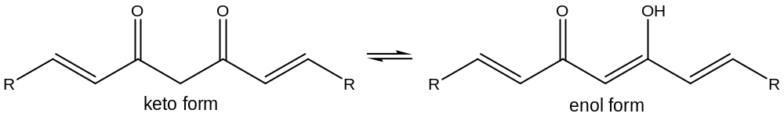  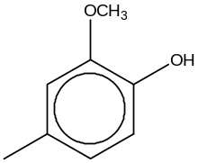  where R represents
 |  | (i) | It was discovered that the percentage of the keto form increases as the temperature increases. Would you expect the enthalpy change of reaction to be exothermic or endothermic? Explain your answer.
 |  | (ii) | The enol form of curcumin is more stable than the keto form. By considering the bonding, suggest a possible reason.
 |  | Curcumin can be used as a pH indicator. In acidic (pH < 7) solutions, it turns yellow whereas in basic (pH > 8.6) solutions, it turns bright red.
 |  | (iii) | Suggest the final colour of the solution containing a few drops of curcumin when 25 cm³ of 1.0 mol dm⁻³ NH₃ was added to 25 cm³ of 1.0 mol dm⁻³ HCl.
 |  | Studies have suggested a wide range of potential therapeutic or preventive effects associated with curcumin. However recent studies have shown that curcumin suppresses the protein hepcidin, potentially causing iron deficiency by forming a complex with iron cations. |  |  |  |  |  |  |  |  |  |  |  |  |  |  | For Examiner’s Use
 |  | (iv) | Explain why iron cations are able to form complexes.
 |  | (v) | Use the Data Booklet to explain the relative stabilities of the Fe(II)/Fe(III) oxidation states in the presence of sodium cyanide.
 |  |  | [8]
 | (b) | The characteristic odour and flavour of ginger is caused by a mixture of zingerone, shogaol and gingerol, volatile oils that compose one to three percent of the weight of fresh ginger. Their structures are given below.  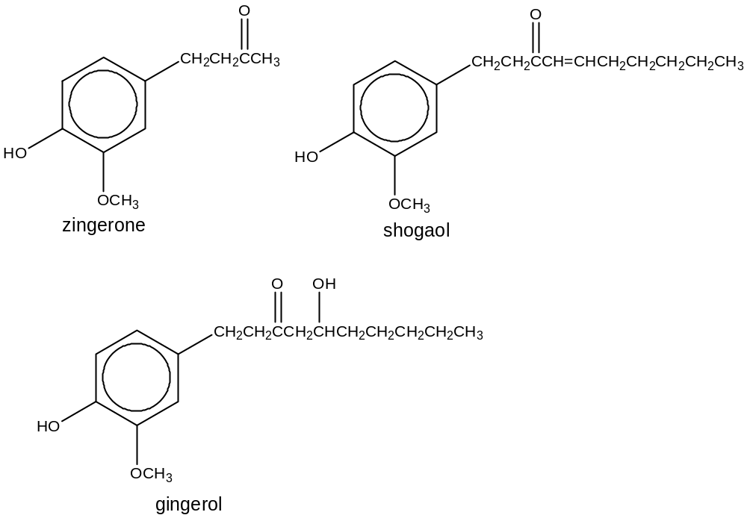 |  |  |  |  |  |  |  |  |  |  |  |  |  |  | For Examiner’s Use
 |  | (i) | Suggest suitable reagents and conditions that can be used to convert shogaol to gingerol in the laboratory.
 |  | (ii) | Suggest a chemical test to distinguish gingerol from the other two compounds. Describe clearly what you see.
 |  | (iii) | Suggest suitable reagents and conditions for the following reaction scheme involving zingerone. Draw the structural formulae for the intermediates A and B.  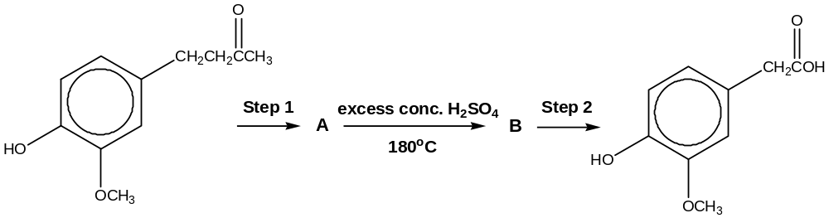  zingerone |  |  |  |  |  |  |  |  |  |  |  |  |  | For Examiner’s Use
 |  |  | Step 1
 |  |  | Step 2
 |  |  | A |  |  |  |  |  |  |  |  | B
 |  |  | [7]
 | (c) | The active component in galangal is given below.  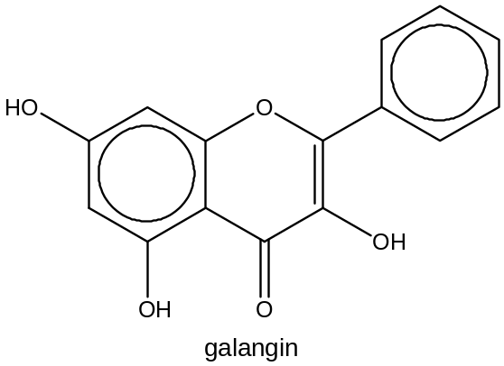  Galangin was reacted with hydrogen gas in the presence of a nickel catalyst at elevated pressure and temperature. State the number of chiral carbons present in the product formed.
[1]

[Total: 16]
6 | (a) | Trimecaine, one of the first clinical local anesthetics drug administered for surgery has the following structure.  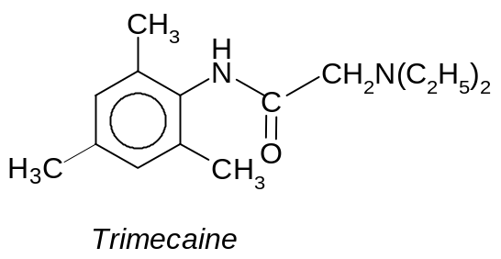 |  |  |  |  |  |  |  |  |  |  |  |  |  |  | For Examiner’s Use
 |  | (i) |  | One molecule of trimecaine contains two nitrogen atoms. Circle the nitrogen atom(s) which you think will cause trimecaine to be basic in nature. Explain your reasoning.
 |  | (ii) |  | Deduce the structural formula of the organic product formed when trimecaine is treated with HCl at room temperature.
 |  | (iii) |  | Suggest a synthetic pathway (of not more than two steps) for the formation of trimecaine from compound Y. Suggest appropriate reagents and conditions as well as structures of any intermediates formed.  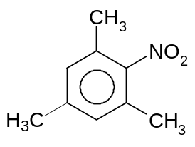  Compound Y |  |  |  |  |  |  |  |  |  |  |  |  | For Examiner’s Use
 |  |  |  | [7]
 | (b) | Amylocaine is another local anesthetic drug administered during surgery. It is used mostly in spinal anesthesia and has the following structure.  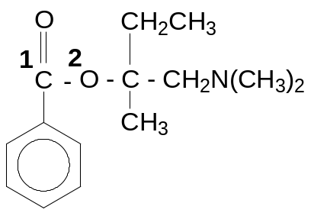 |  |  |  |  |  |  |  |  |  |  |  |  |  |  | For Examiner’s Use
 |  | (i) |  | State the shape of the amylocaine molecule with respect to the carbon that is labelled as ¹C and the oxygen atom that is labelled as ²O respectively.
 |  |  |  | Shape with respect to carbon ¹C
 |  |  |  | Shape with respect to oxygen ²O
 |  | (ii) |  | State the type of hybridization with respect to carbon ¹C and sketch the shape of the hybrid orbitals around carbon ¹C atom in the amylocaine molecule.
 |  |  |  | Type of hybridization of carbon ¹C atom
 |  |  |  | Sketch of hybrid orbitals
 |  | (iii) |  | Amylocaine undergoes enzymic hydrolysis rapidly in the small intestines when the pH is about 8. Draw the structural formulae of the products obtained from the hydrolysis.
 |  |  |  | [4]
 |  |  |  | [Total: 11]

